## Exercise 1.1: Recipe Book (Basic layout)

You will create a small app to view and create recipes. In this exercise we will start with creating a basic layout to view a recipe:

* Create a new project. Try to organize your project structure using subfolders for different class types (for example activities, models, services, etc.).
* Rename the *MainActivity* class to *RecipeDetailsActivity* and the layout file *activity_main.xml* to *activity_recipe_details.xml*. Open the layout.
* In the text view change the root element to a linear layout and set an attribute *android:orientation=“vertical“.* The result should look similar to this:

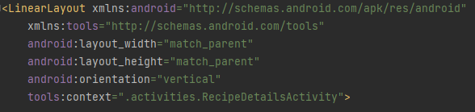

* In the Designer view add text views for the recipe’s name, country of origin, ingredients and instructions properties and a button to cycle through available recipes. You can also directly drag elements into the Component Tree if you want. The controls will automatically be arranged as a vertical list.
* Set values for initial text and an id for each of your UI elements.
* Test your layout by starting the app with the emulator or a real device.

The result Component Tree could look something like this:

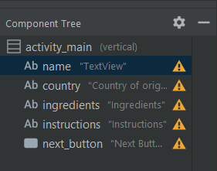

## Exercise 1.2: Add recipes to your book

In this exercise you will add a list of recipes to your book, select the first one on the list and show it in the UI from 1.1.

* Copy the classes *Recipe* and *RecipeCollection* from the Materials folder. Get familiar with them. You will notice that RecipeCollectionis implemented as a singleton, meaning there is only one instance of this class in the whole application. This will be useful in later exercises. To get that instance use *RecipeCollection.getInstance()*.

The RecipeCollection class has some hard coded recipes. You can use them for the first few exercises. Feel free to change them or add new ones.

* In your activityin *onCreate()* get the instance of RecipeCollection and use *getNextRecipe(null)* to fetch thefirst recipe (with index 0)*.* Afterwards, find the text views and set their texts accordingly using the data from the Recipe object.

## Exercise 1.3: Add the functionality to cycle through the list of recipes

The user should be able to go through the list of recipes by pressing the Next button. When the button is clicked the next recipe from the should be taken from RecipeCollection and its details should be loaded into the corresponding text views and shown on the UI.

## Exercise 1.4: Create a more interesting UI (optional)

Play a bit with the UI settings. Try changing the properties of the text views and the button in order to make the activity more readable. You can try changing the text font, adding different text properties (bold, italic, etc.), adding padding and/or margin. If the content of the page becomes too big to fit on your phone’s screen, you can wrap the linear layout with a scroll view to make the activity scrollable.